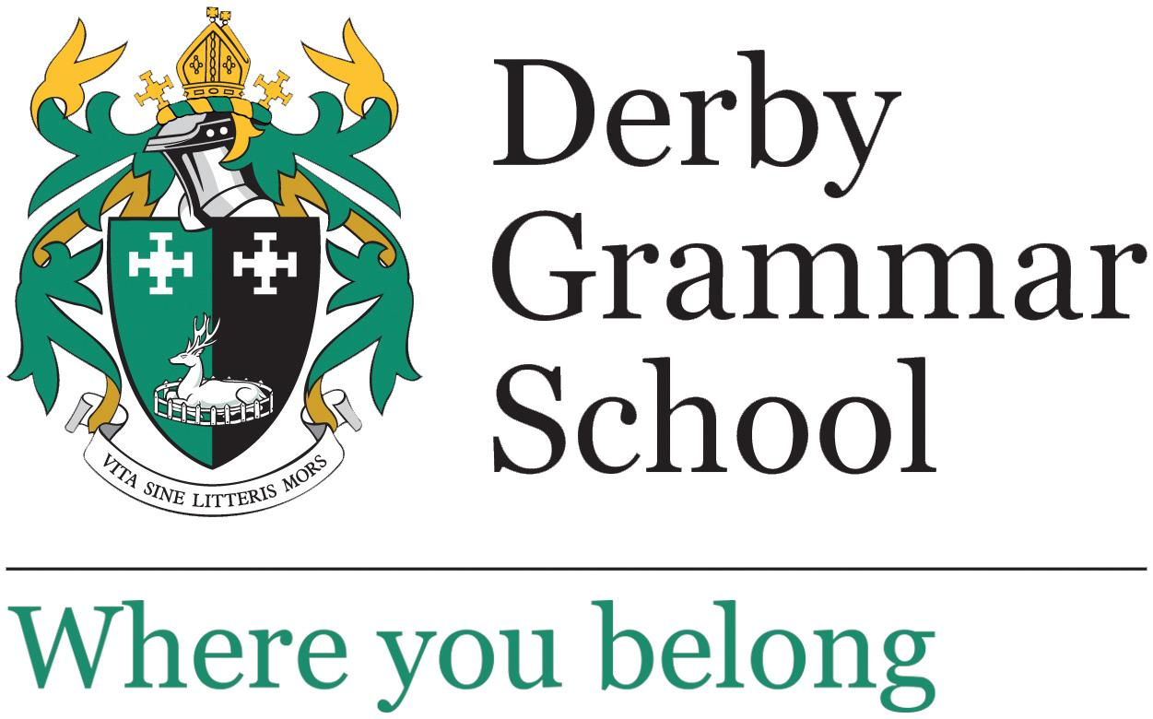

Teacher of Chemistry

Permanent

Full time

Start: September 2025

Salary: Derby Grammar School pay scale

Applications from ECTs are welcome

Closing date: Monday 21 April 2025, 4 pm

This is an exciting opportunity for a Teacher of Chemistry to join our Science Department. We are a small yet supportive team of highly committed staff.

The successful candidate will be an excellent classroom teacher, with the ability to inspire and challenge all pupils to achieve their full potential. We are particularly keen to hear from teachers who have a passion for co-curricular activities.

Derby Grammar School is a coeducational all-through school from Reception to Sixth Form. We enjoy small class sizes and a family feel with positive and constructive working relationships with our students. Science is studied by all pupils in Key Stage 3, and the majority of our students take the separate sciences at GCSE with a small proportion opting for GCSE Combined Science.

Chemistry is a popular subject at Derby Grammar School and we take great pride in supporting and encouraging our students in their education and celebrating their successes.

At Key Stage 3 (Year 7, Year 8 and Year 9), all pupils follow departmental schemes of work based upon the Exploring Science resources. Pupils are taught in small mixed ability classes and have three 55-minute periods of science per week with one teacher.

At GCSE we offer the Pearson/Edexcel specification. Pupils are taught for two or three 55-minute periods per science per week, delivered by subject specialist teachers whether pupils are studying GCSE Chemistry or GCSE Combined Science.

At A Level the department offers the OCR Chemistry A specification and it is a popular choice of A Level for our sixth form students. Pupils are taught for five 55-minute periods per week in Year 12 and six 55-minute periods per week Year 13. The lessons are split between two Chemistry teachers.

The School has six well-equipped laboratories, two for each science. Class sizes are small and we enjoy positive and constructive working relationships with our students and benefits from excellent technician support.